GlobalTech Cybersecurity Internship
OPERATION GLASS VAULT
Week 7 — Web Application Penetration Testing (OWASP Top 10 Assessment)
Prepared by: Hamzat Habeeb Adeyemi
Client (simulated): CyberVault Technologies — Nigerian Fintech Startup

Commissioned by: Mr. Femi, GRC Specialist | Supervised by: Temitope Toheeb, Head of Red Team

D1 — Reconnaissance & Scoping Document

1. Engagement Overview

This document is about scoping a web application penetration test for CyberVault Technologies. They are a Nigerian fintech startup that works with GlobalTech. It ties into the cybersecurity internship program in cohort 1 and something called Operation Glass Vault. Mr Femi who handles GRC stuff commissioned the work. That came after a compliance gap review from week 5 in the governance part of the program. The review showed that none of the clients in the portfolio had gone through a formal OWASP top 10 check before. CyberVault ended up being the first one where this gets tested out. It feels like the recommendation from that earlier analysis is finally getting put to use here. Some parts of how the engagement started still seem a bit unclear though.

Authorization Statement
Temitope Toheeb gave the go ahead as head of red team at GlobalTech and this is on behalf of CyberVault Technologies for the internship setup. It covers the testing work on DVWA along with Mutillidae II which sit on the metasploitable instance at that address. The window starts monday the thirty first of august and runs through friday the fourth of september twenty twenty six up to six in the evening WAT. Nothing happens outside those days and times. It only applies to the ten items listed for probing and it does not reach any other systems or hosts. It seems the whole thing can be pulled back or adjusted at any point by him. I think that keeps things limited but maybe some details on exactly how the testing gets done could shift.

In-Scope Systems
- DVWA (Damn Vulnerable Web Application) — representing the CyberVault Customer Banking Dashboard
- Mutillidae II — representing the CyberVault Internal Admin Portal & Authentication Layer
- Both hosted on the Metasploitable2 instance used for this internship's lab environment

Out-of-Scope
- Any other service running on the Metasploitable2 host
- Pivoting or lateral movement to any other host on the network
- Denial-of-service testing of any kind

2. Rules of Engagement

Authorized Techniques
- Manual testing via browser and browser developer tools
- Intercepting proxy (Burp Suite Community) for request inspection and manipulation
- Scripted proof-of-concept requests via curl
sqlmap was used in one instance (D3, Finding 5), and only after the injection point was first confirmed manually — consistent with the brief's requirement that automated tooling supplement, not replace, manual proof-of-concept.

Explicitly Excluded Techniques

Escalation Path
If testing surfaces a finding outside the agreed scope, or of unexpected severity, testing on that finding stops immediately and is reported to Temitope Toheeb, Head of Red Team, before any further action is taken on it.

3. Target Environment Documentation

Addressing
Metasploitable2 instance primarily addressed at 10.10.1.254 for both DVWA (/dvwa/) and Mutillidae II (/mutillidae/).

DVWA Security Level
Security Level: Low, used throughout all five DVWA findings
Low was picked since it turns off the checks on input and output. This made it easy to show the problems were there. All the tests went through right away. It does not show what an attacker could really do though. The higher settings put some of the protections back. They add things like stripping words and handling queries better in places. Forms get captcha too. A production system would probably be even stricter than that high level. The code has the basic flaws like string based sql and no encoding on output. Commands from input too. These results confirm the issues exist in the codebase. They are not really a measure of exploit steps needed. I think the priority for fixing stays the same. The defects in the code are what matter.

Mutillidae Version & Configuration
Version 2.1.19, Security Level 0 ("Hosed"), Hints Disabled.

Tooling
- Browser + DevTools
- Burp Suite Community Edition (v2026.2.3),
- sqlmap

4. Reconnaissance Findings

Technology Fingerprinting
DVWA: Apache, PHP, MySQL 5.0.51a-3ubuntu5 (identified via SQL Injection UNION-based version() extraction, D2 Finding 1). Mutillidae: PHP 5.2.4-2ubuntu5.10 (disclosed directly in the application footer).

Vulnerability-to-Location Mapping
Each of the ten in-scope vulnerabilities and its expected test location:
Target | # | Vulnerability | OWASP 2021
DVWA | 1 | SQL Injection | A03:2021
DVWA | 2 | XSS — Reflected | A03:2021
DVWA | 3 | XSS — Stored | A03:2021
DVWA | 4 | Command Injection | A03:2021
DVWA | 5 | File Inclusion (LFI/RFI) | A05:2021
Mutillidae | 1 | Broken Authentication | A07:2021
Mutillidae | 2 | IDOR | A01:2021
Mutillidae | 3 | Security Misconfiguration | A05:2021
Mutillidae | 4 | CSRF | A01:2021
Mutillidae | 5 | SQL Injection (2nd vector) | A03:2021

D2 — Technical Findings Report: DVWA

Summary
Testing against DVWA at security level Low confirmed all five in-scope vulnerability classes across the customer banking dashboard's SQL Injection, reflected and stored Cross-Site Scripting, Command Injection, and File Inclusion surfaces. Every finding was reproduced with a verbatim payload and screenshot evidence. At Low security level, the application applies effectively no input validation or output encoding, meaning these findings demonstrate the presence of each underlying flaw with high confidence, though the ease of exploitation shown here would be reduced — not eliminated — against DVWA's Medium or High settings. The most severe finding, Command Injection, grants direct OS-level command execution and represents a full path to host compromise; taken together, these findings indicate the dashboard's current input-handling posture would not withstand even unauthenticated, low-skill attack attempts in its current (Low-equivalent) configuration.
# | Finding | OWASP 2021 Category | Severity
1 | SQL Injection | A03:2021 — Injection | High
2 | XSS — Reflected | A03:2021 — Injection | Medium
3 | XSS — Stored | A03:2021 — Injection | High
4 | Command Injection | A03:2021 — Injection | Critical
5 | File Inclusion (LFI) | A05:2021 — Security Misconfiguration | High

- FIDING 1: SQL INJECTION

OWASP 2021 Category: A03:2021 — Injection
Affected Location
SQL Injection module — "User ID" parameter (id), submitted via GET to /dvwa/vulnerabilities/sqli/.
Steps to Reproduce
1. Submit id=1 as a baseline — returns exactly one record (First name: admin, Surname: admin).
2. Submit id=1' — application returns a raw MySQL syntax error, confirming the input is concatenated directly into the query with no sanitization.
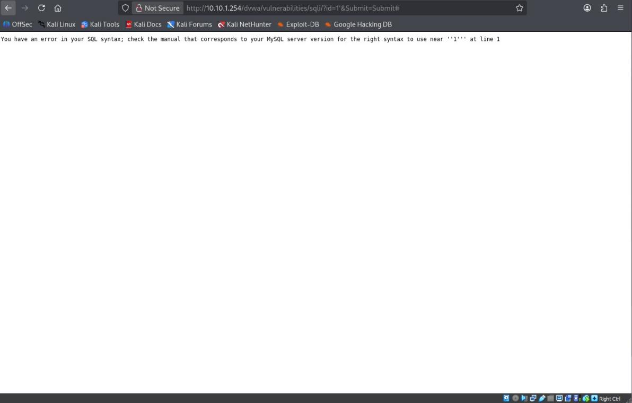
Figure 1.1 — Unsanitized quote breaks the query, exposing a raw MySQL syntax error.
3. Submit id=1' OR '1'='1 — the boolean-true condition causes the query to return all five user records instead of one, confirming the injection point can alter query logic.
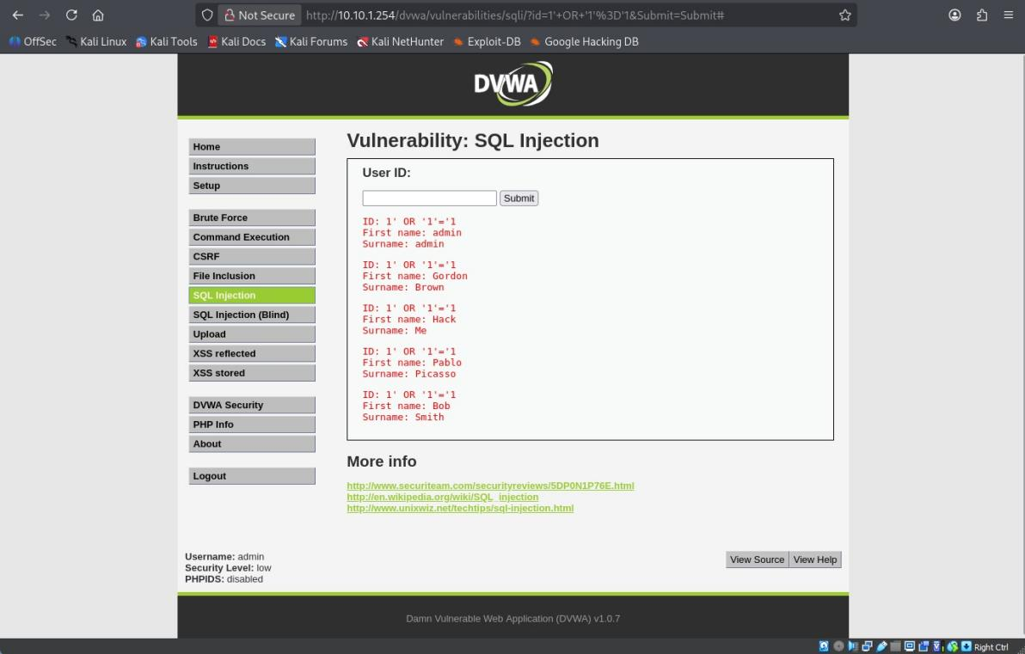
Figure 1.2 — Boolean-based injection returns all five DVWA user records (admin, Gordon Brown, Hack Me, Pablo Picasso, Bob Smith).
4. Submit id=1' UNION SELECT database(), version()-- - — extracts the active database name and MySQL version alongside the legitimate admin record.
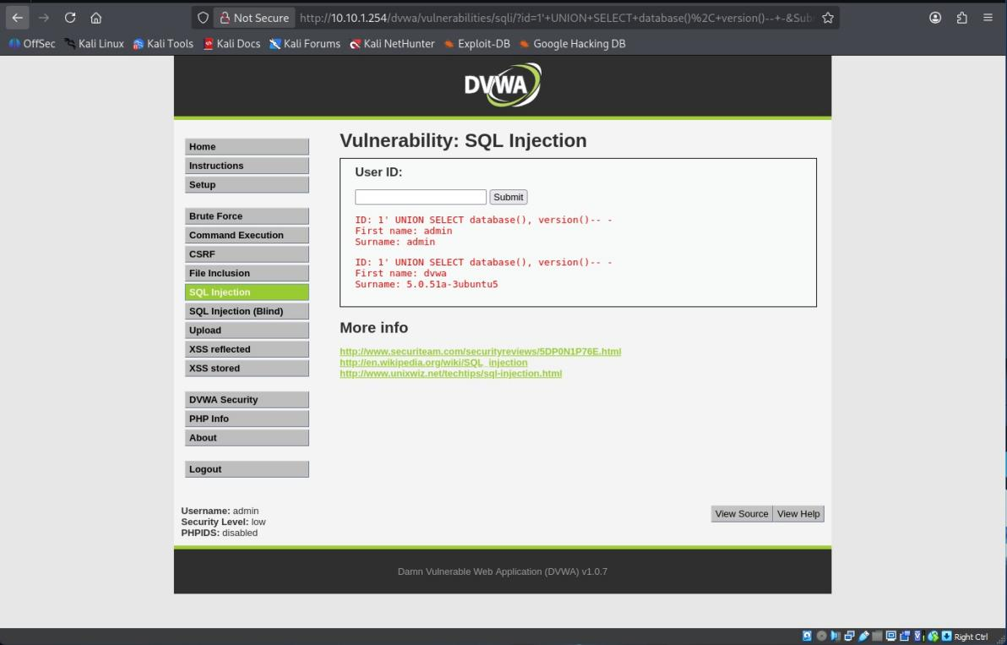
Figure 1.3 — UNION-based extraction returns database name "dvwa" and MySQL version "5.0.51a-3ubuntu5".
Proof-of-Concept Payload
1' UNION SELECT database(), version()-- -
Impact Assessment
On a customer banking dashboard, this class of injection would allow an attacker to enumerate the underlying database schema and extract data from any table reachable by the application's database account — potentially including customer account records, balances, or transaction history — without any valid application credentials, using only the exposed User ID field.
Severity: High — trivially exploitable with no authentication barrier bypassed beyond the vulnerable field itself, and demonstrated data extraction beyond the intended query scope; not rated Critical only because this specific field did not directly yield credential or PII tables during testing.
Remediation Recommendation
Replace string-concatenated SQL with parameterized queries / prepared statements (e.g. PDO prepared statements in PHP) for every query built from user-supplied input. Do not rely on input filtering alone.

FINDING 2: CROSS-SITE SCRIPTING - REFLECTED

OWASP 2021 Category: A03:2021 — Injection
Affected Location
XSS (Reflected) module — "name" parameter, submitted via GET to /dvwa/vulnerabilities/xss_r/.
Steps to Reproduce
1. Submit name=testname123 as a baseline — value is reflected directly into the page ("Hello testname123") with no encoding.
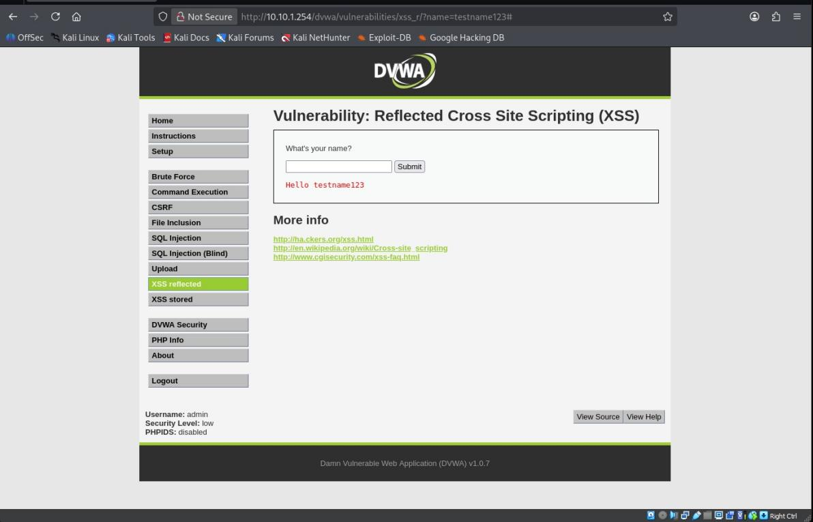
Figure 2.1 — Baseline confirms unsanitized reflection of the name parameter.
2. Submit name=<script>alert('YOU HAVE BEEN HACKED')</script> — the script executes immediately on page load.
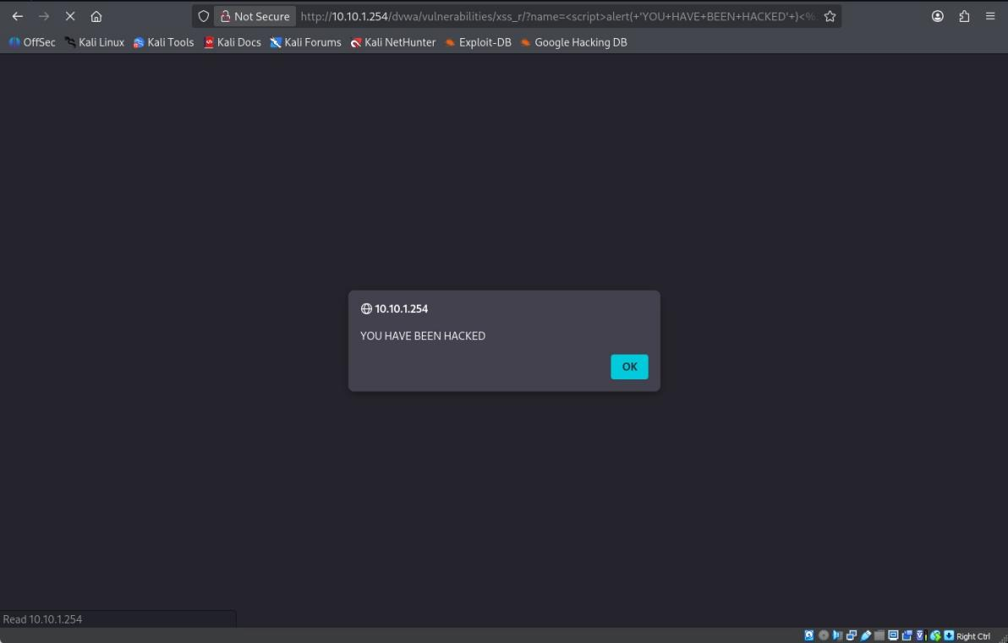
Figure 2.2 — Injected script executes, producing a browser alert box reading "YOU HAVE BEEN HACKED".
3. Navigating away and returning to the page without resubmitting the payload does not reproduce the alert, confirming the vulnerability is reflected (non-persistent) rather than stored.
Proof-of-Concept Payload
<script>alert('YOU HAVE BEEN HACKED')</script>
Impact Assessment
On a customer-facing banking dashboard, this vulnerability is exploitable via a crafted link sent to a logged-in customer (e.g. through phishing). If clicked while authenticated, the script would execute in the customer's session context — enabling session token theft, forced actions, or credential-harvesting overlays presented as legitimate dashboard content.
Severity: Medium — requires social engineering (a victim must click a crafted link) to weaponize, unlike stored XSS which needs no victim interaction beyond a normal page visit.
Remediation Recommendation
Apply context-aware output encoding (e.g. htmlspecialchars() in PHP) to all user-supplied data before it is rendered into HTML. Additionally deploy a Content-Security-Policy header restricting inline script execution.

- FINDING 3: CROSS-SITE SCRIPTING - STORED

OWASP 2021 Category: A03:2021 — Injection
Affected Location
XSS (Stored) module — guestbook "Message" field, submitted via POST to /dvwa/vulnerabilities/xss_s/.
Steps to Reproduce
1. Submit a baseline guestbook entry (Name: test, Message: a plain comment) and confirm it appears in the guestbook list below the form.
2. Submit Message: <script>alert('hacked XSS')</script> — the script executes immediately upon submission.
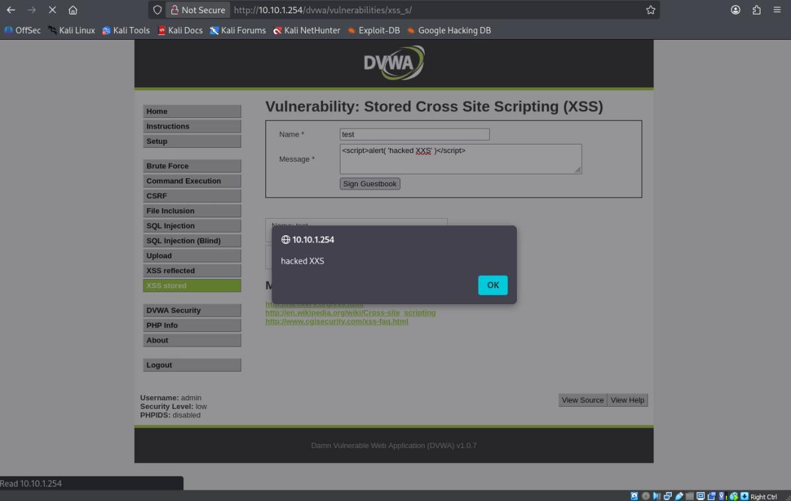
Figure 3.1 — Injected script executes on submission, producing an alert box reading "hacked XSS".
3. The guestbook retains prior entries across submissions, confirming the message store persists server-side rather than being session-local.
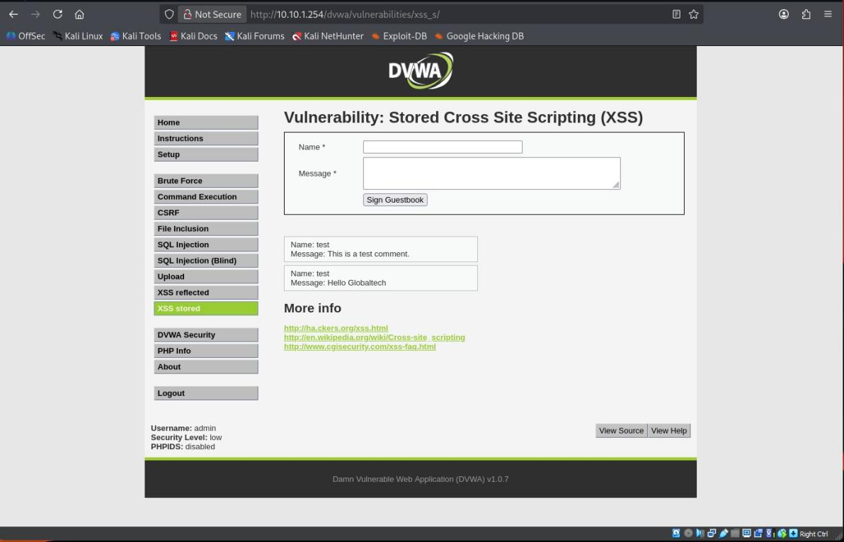
Figure 3.2 — Guestbook list showing persisted entries across page loads.
Proof-of-Concept Payload
<script>alert('hacked XSS')</script>
Impact Assessment
Because the payload is stored and rendered to any visitor of the guestbook page, this vulnerability would execute against every customer or staff member who later views the affected page — no phishing or victim interaction required. In a banking-dashboard context, an equivalent stored field (e.g. a support-ticket note or transaction memo) could be weaponized to hijack the session of any user — including an admin — who later views that content.
Severity: High — no victim interaction required beyond a normal page visit, and the payload persists to affect an unbounded number of future viewers, unlike the single-shot reflected variant above.
Remediation Recommendation
Apply output encoding on render (not just input validation on submit) for all persisted user content, and consider a strict Content-Security-Policy disallowing inline <script> execution as defense in depth.

- FINDING 4: COMMAND INJECTION

OWASP 2021 Category: A03:2021 — Injection
Affected Location
Command Execution module — "ip" parameter (Ping for FREE feature), submitted via POST to /dvwa/vulnerabilities/exec/.
Steps to Reproduce
1. Submit a valid IP (127.0.0.1) as a baseline — returns standard ping output (packet stats, RTT).
2. Submit 127.0.0.1 && whoami — the chained command executes alongside the ping.
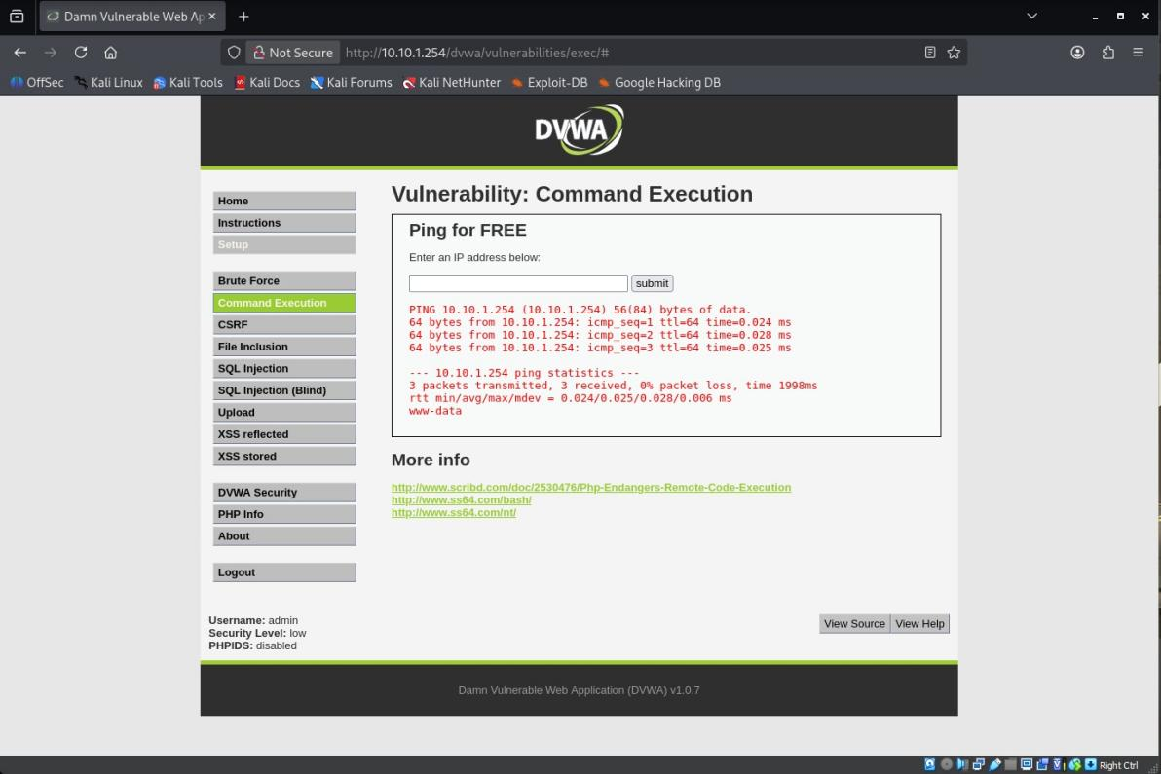
Figure 4.1 — Ping output followed by the appended output of the whoami command (www-data), confirming arbitrary OS command execution.
Proof-of-Concept Payload
127.0.0.1 && whoami
Impact Assessment
This finding grants OS-level command execution on the underlying server hosting the banking dashboard well beyond application-layer data access. An attacker could use this to read configuration files (including database credentials), plant a webshell for persistent access, pivot to other internal hosts, or exfiltrate the entire application's data store directly from the filesystem.
Severity: Critical — unauthenticated-equivalent (once any session is available) remote command execution with no chaining or further exploitation required — this is full host compromise, the most severe outcome possible from a single input field.
Remediation Recommendation
Do not shell out to OS commands built from user input. Where a system call is unavoidable, use an allow-list of expected input formats (e.g. strict IPv4 regex validation) combined with parameterized execution APIs (e.g. escapeshellarg()) rather than string concatenation into a shell command.

- FINDING 5: FILE INCLUSION (LFI)

OWASP 2021 Category: A05:2021 — Security Misconfiguration
Affected Location
File Inclusion module — "page" parameter, submitted via GET to /dvwa/vulnerabilities/fi/.
Steps to Reproduce
1. Confirm baseline behavior via the default ?page=include.php link, which loads one of three intended include files.
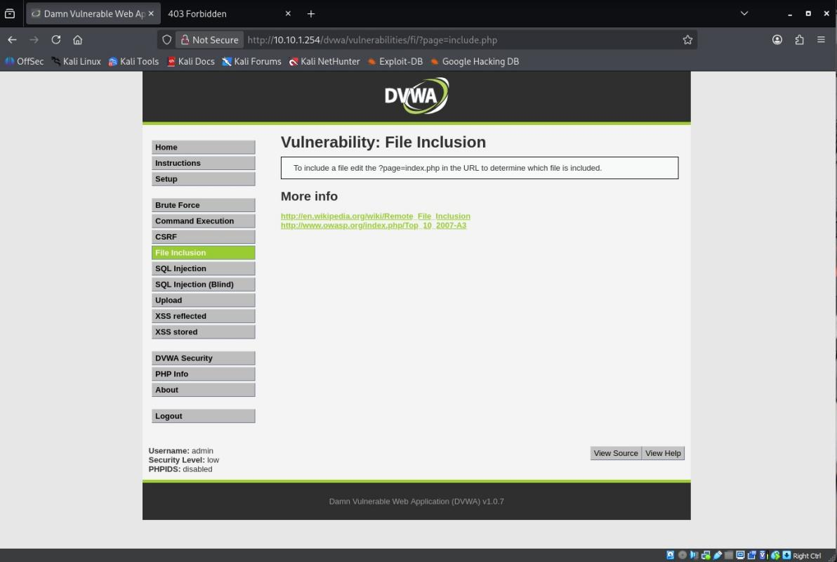
Figure 5.1 — Baseline File Inclusion module, confirming the page parameter controls which file is loaded.
2. Replace the page parameter with a path-traversal payload: ?page=/etc/passwd. The contents of the system's /etc/passwd file render directly in the browser.
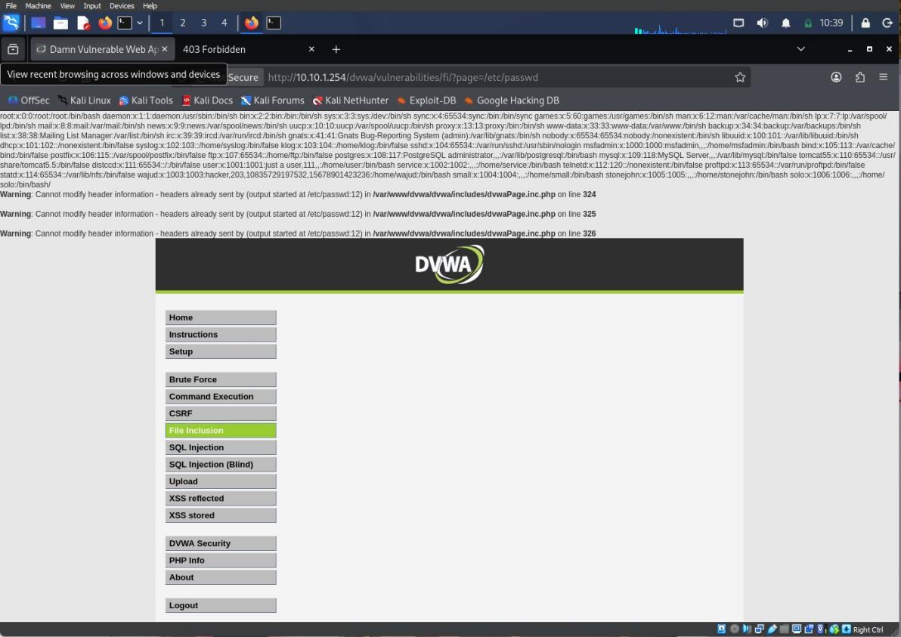
Figure 5.2 — Contents of /etc/passwd rendered in-browser via the page parameter, confirming Local File Inclusion (LFI). PHP warnings visible above the output additionally disclose the full server filesystem path (/var/www/dvwa/includes/dvwaPage.inc.php).
Variant used: Local File Inclusion (LFI), confirmed by reading a file local to the server filesystem. Remote File Inclusion (RFI) was not tested against this target, as DVWA's default PHP configuration disables allow_url_include, and RFI testing was considered out of proportion to the LFI proof already obtained within the authorized scope.
Proof-of-Concept Payload
http://10.10.1.254/dvwa/vulnerabilities/fi/?page=/etc/passwd
Impact Assessment
LFI on an admin-facing or customer-facing portal typically escalates beyond reading /etc/passwd: the same technique against DVWA's own configuration file would expose database credentials directly. For CyberVault, an equivalent flaw on the admin portal could expose configuration secrets, session-handling keys, or API credentials — a direct path from "read a file" to full application compromise.
Severity: High — unauthenticated file disclosure with a clear escalation path to credential exposure; not rated Critical in this instance only because the specific file read here (/etc/passwd) did not itself contain live application credentials.
Remediation Recommendation
Avoid passing user input directly into file-inclusion functions. Where dynamic includes are required, validate against a strict allow-list of permitted filenames rather than accepting arbitrary paths, and disable allow_url_include in php.ini regardless.

Findings Synthesis

Most Severe Finding
Command Injection is the most severe of the five findings. Unlike the SQL Injection and File Inclusion findings — which expose data — Command Injection grants direct execution of arbitrary operating system commands on the host itself, which is a strictly greater capability: an attacker with OS command execution can subsequently read any file the SQLi or LFI findings could reach, modify the application, or pivot further into CyberVault's infrastructure. It is rated Critical while the others top out at High.

Finding Chains
Reflected XSS could be chained with the Stored XSS finding's session-hijacking impact: an attacker could use the Reflected XSS field to steal a victim's session cookie via a phishing link, then use that hijacked session to submit further payloads through the Stored XSS guestbook that persist against other users — expanding a single-victim reflected attack into a persistent, multi-victim campaign. Separately, the File Inclusion finding's exposure of full server file paths (visible in the PHP warning output) would materially assist an attacker attempting to escalate the Command Injection finding, since knowing the exact web-root path reduces guesswork when planting or locating a webshell.

Next Investigative Step
With additional time, the priority would be confirming whether the Command Injection finding can be escalated to a reverse shell (rather than one-off command output), and whether the database account used by the SQL Injection finding has FILE privilege — which would allow reading server files directly through SQLi as an alternative path to the same outcome demonstrated via Command Injection and LFI, strengthening the case that these three findings share a common root cause (unsanitized user input reaching sensitive interpreters) rather than being three unrelated issues.

D3 — Technical Findings Report: Mutillidae II

Summary
Testing started with Mutillidae II at version 2.1.19 and security level zero on the admin portal. Four vulnerability classes showed up out of five. Broken authentication came through complete sql injection for login bypass. Insecure direct object reference let files get read without permission using the source code viewer. Verbose php errors from misconfiguration revealed the server file path inside. There was also another sql injection on account lookup that worked separately from the first. Three findings rated critical or high. Each one could compromise the portal all by itself. The sql injections especially because one fix would not cover both. That part gets a bit messy when thinking about what to patch first. Cross site request forgery stayed not tested since the window ran out. It should not count as a clean pass or anything like that.
# | Finding | OWASP 2021 | Severity
1 | Broken Authentication | A07:2021 | Critical
2 | Insecure Direct Object Reference (IDOR) | A01:2021 | High
3 | Security Misconfiguration | A05:2021 | High
4 | Cross-Site Request Forgery (CSRF) | A01:2021 | Not Completed
5 | SQL Injection (2nd vector) | A03:2021 | Critical

- FINDING 1: BROKEN AUTHENTICATION

OWASP 2021 Category: A07:2021 — Identification and Authentication Failures
Affected Location
Login page (OWASP Top 10 → A3 - Broken Authentication and Session Management → Login) — "Name" field of the sign-in form.
Steps to Reproduce
1. Navigate to Login/Register → Please sign-in.
2. In the Name field, submit ' OR 1=1-- ; enter any value in the Password field (the payload comments out the password check entirely, so its value is irrelevant).
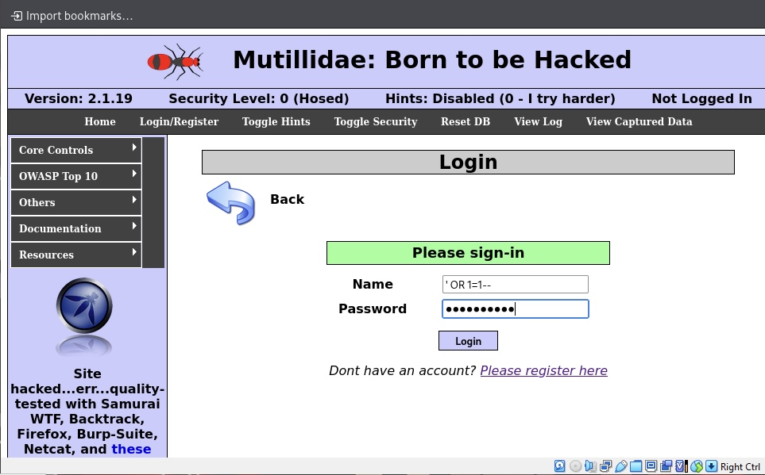
Figure 1.1 — Login form submitted with ' OR 1=1-- in the Name field.
3. Click Login. The application authenticates the session as the admin account with no valid credential supplied.
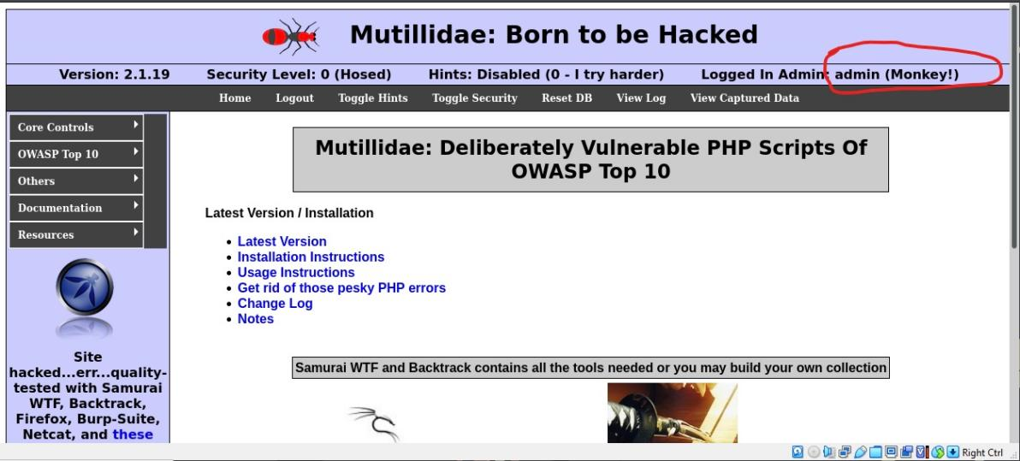
Figure 1.2 — Top banner now reads "Logged In Admin: admin (Monkey!)", confirming full authentication bypass.
Proof-of-Concept Payload
' OR 1=1--
Impact Assessment
This is a complete authentication bypass on the internal admin portal's login mechanism: the underlying login query is built by concatenating the Name field directly into a SQL WHERE clause, so the injected OR 1=1-- condition satisfies the query regardless of any real credential and the trailing comment strips the password check entirely. An attacker with no valid username or password reaches full admin-level access in a single request — directly compromising the trust boundary the internal admin portal exists to protect, with no further steps or chaining required.
Severity: Critical — zero valid credentials required, full administrative access achieved in one request — this is as severe as an authentication control can fail.
Remediation Recommendation
Replace the string-concatenated login query with parameterized queries / prepared statements, identical to the fix required for the SQL Injection findings in D2 and Finding 5 below. As defense in depth, add account lockout after repeated failed attempts and generic (non-revealing) error messages on login failure.

- FINDING 2: INSECURE DIRECT OBJECT REFERENCE (IDOR)

OWASP 2021 Category: A01:2021 — Broken Access Control
Affected Location
Source Code Viewer module (OWASP Top 10 → A4 - Insecure Direct Object References → Source Code Viewer) — the "Source File Name" selector on index.php?page=source-viewer.php.
Steps to Reproduce
1. Navigate to Source Code Viewer and use the default selection (show-log.php) with View File — confirms the feature returns the source of an intended, in-scope application file.
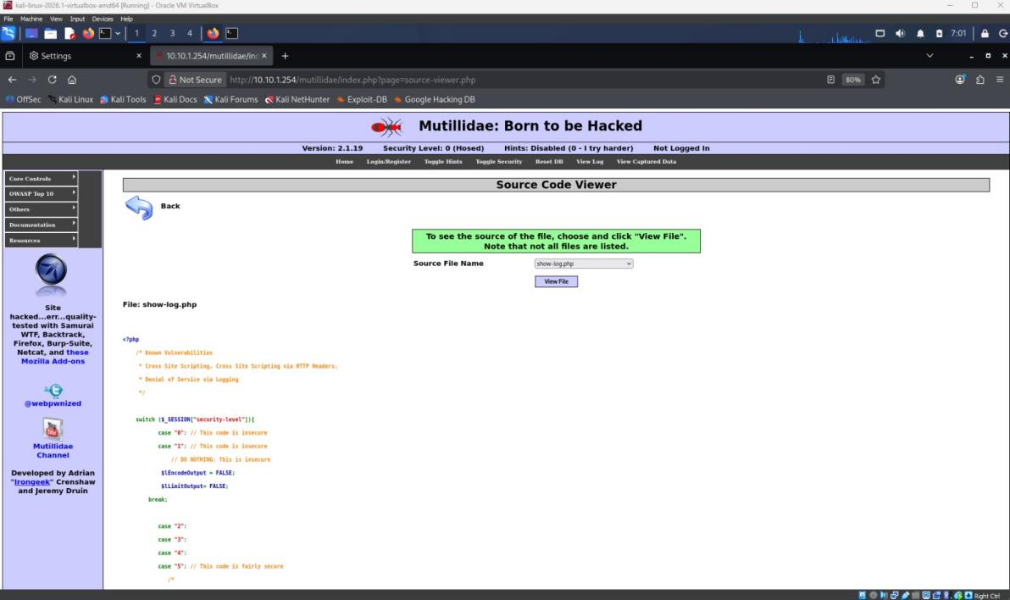
Figure 2.1 — Baseline: selecting show-log.php returns that file's legitimate PHP source, confirming normal intended behavior.
2. Tamper the underlying file reference to a path-traversal value targeting a file outside the intended source directory: ../../../../etc/passwd.
3. Submit — the application dereferences the tampered value directly with no ownership or path check, and renders the contents of /etc/passwd instead of application source.
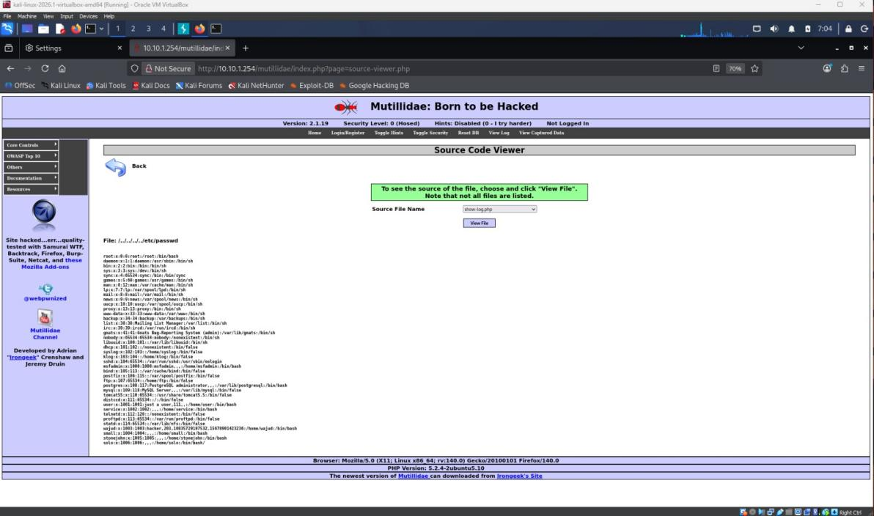
Figure 2.2 — Tampered file reference (../../../../etc/passwd) returns the system's /etc/passwd contents, confirming the object reference is accepted with no authorization check against the intended file set.
Proof-of-Concept Payload
../../../../etc/passwd
Impact Assessment
The Source File Name parameter is a direct, unauthorized object reference: the application trusts the client-supplied value to select which file to read, with no check confirming the requested value belongs to the intended set of application source files. On an internal admin portal, this class of flaw typically extends to record or account identifiers rather than files — but the underlying failure (trusting a client-supplied reference with no server-side ownership check) is identical, and here it grants direct filesystem read access outside the application's intended scope, which could be escalated to read configuration files containing credentials.
Severity: High — unauthenticated, no-interaction file disclosure via a trivially tampered parameter; not rated Critical here as the specific file read did not itself contain live application credentials, matching the same reasoning applied to the DVWA LFI finding.
Remediation Recommendation
Replace the free-text/path-accepting file selector with a server-side allow-list mapping selectable values (e.g. an integer ID or fixed enum) to specific, intended file paths — never resolve a client-supplied path or filename directly against the filesystem.

- FINDING 3: SECURITY MISCONFIGURATION

OWASP 2021 Category: A05:2021 — Security Misconfiguration
Affected Location
Text File Viewer module (index.php?page=text-file-viewer.php), triggered when the server's outbound fopen() call to the requested URL fails.
Steps to Reproduce
1. Navigate to OWASP Top 10 → A4 - Insecure Direct Object References → Text File Viewer.
2. Select the default option ("Intrusion Detection in Computers by Victor H. Marshall") and click View File without modification.
3. Because the lab environment has no outbound internet access, the server-side fopen() call to the remote textfiles.com URL fails, and the application surfaces raw, unhandled PHP warnings directly to the browser instead of a generic error message.
Proof-of-Concept Payload
No crafted payload was required — this finding surfaces from the application's default, unmodified behavior under a failure condition (default file selection, default View File submission).
Impact Assessment
The application discloses its full server-side filesystem path (/var/www/mutillidae/text-file-viewer.php), internal function names (fopen, stream_get_contents, fclose), and line numbers directly to an unauthenticated visitor. On an internal admin portal, this level of verbose error disclosure gives an attacker a head start on further attacks — confirming the exact web-root path materially assists exploitation of other findings (e.g. narrowing the target path for a webshell drop if a code-execution vulnerability is later found), and confirms the application runs with display_errors enabled in a way no production system should permit.
Severity: High — does not itself grant code execution or data access, but meaningfully assists further exploitation by disclosing exact internal file paths and confirming verbose PHP error output is enabled — a foundational misconfiguration a real attacker would fingerprint early in an engagement.
Remediation Recommendation
Set display_errors = Off and log_errors = On in php.ini for any production or production-representative environment. Wrap external resource calls (e.g. fopen() against user- or config-supplied URLs) in try/catch or explicit return-value checks that surface a generic, non-disclosing error message to the end user.
- FINDING 4: CROSS-SITE REQUEST FORGERY (CSFR)

OWASP 2021 Category: A01:2021 — Broken Access Control
Status: Not Tested. This finding was not completed within the assessment window and is reported here as an open item rather than a confirmed absence of the vulnerability

- FINDING 5: SQL INJECTION (SECOND VECTOR)

OWASP 2021 Category: A03:2021 — Injection
Affected Location
View Account Details page (index.php?page=user-info.php) — username and password GET parameters. This is a distinct vector from both the DVWA SQLi finding (D2, Finding 1: POST-based id parameter, manually exploited via error-based and UNION-based techniques) and the Broken Authentication finding above (Finding 1: Name field on the login form, exploited manually with a single boolean payload). This finding targets a separate feature entirely, and — unlike the two prior findings, which were both identified and exploited by hand — the full extent of injectable parameters here was confirmed using sqlmap after an initial manual finding, surfacing boolean-blind, error-based, time-based blind, and UNION-query injection types across two parameters.
Steps to Reproduce
1. Navigate to OWASP Top 10 → A1 - Injection (SQL) → View Account Details, and submit a baseline lookup (e.g. username=Mox, password=Password) to confirm normal single-record behavior.
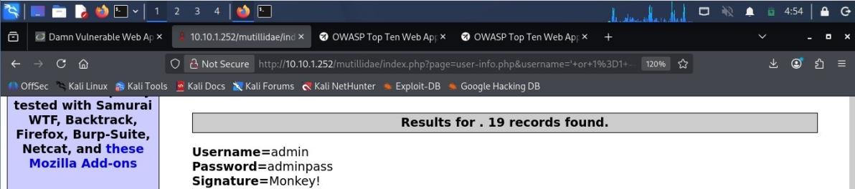
Figure 5.1 — Manual confirmation: submitting username=' or 1=1-- via the Name field returns all account records instead of one ("19 records found"), confirming the injection point before any automated tooling was used.
2. With manual injection confirmed, the request was passed to sqlmap (username and password parameters, GET method) to characterize the full scope of the injection. sqlmap confirmed both parameters are injectable via boolean-based blind, error-based, time-based blind, and UNION query techniques, and enumerated the database schema.
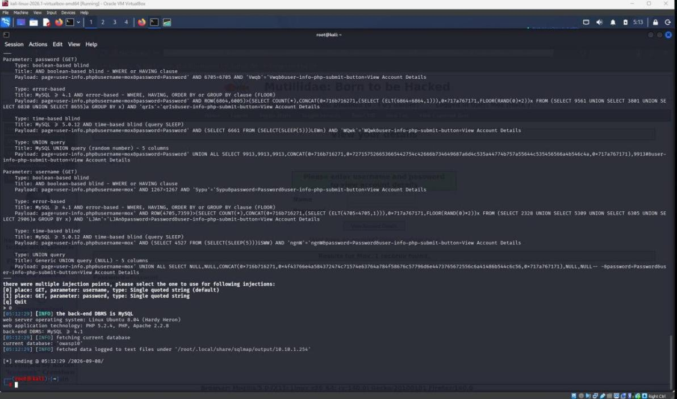
Figure 5.2 — sqlmap enumeration of the owasp10 database: 6 tables identified (accounts, blogs_table, captured_data, credit_cards, hitlog, pen_test_tools).
3. Schema and a single sample row were extracted from the accounts table (columns: cid, is_admin, password, username, mysignature) to confirm data-level access. Extraction was limited to schema plus one representative row rather than a full table dump, despite sqlmap's default behavior returning all 19 records when unrestricted — the additional rows are not reproduced in this report. See D4 Part B for the judgment call this required in the moment.
Proof-of-Concept Payload
Manual: username=' or 1=1--
sqlmap: sqlmap -u "http://10.10.1.254/mutillidae/index.php?page=user-info.php&username=Mox&password=Password" -p username,password --batch
Impact Assessment
This finding demonstrates a second, independently exploitable injection point on the internal admin portal, in a different feature from both the login form and DVWA's dashboard. The accounts table's schema confirms it stores an is_admin flag alongside username and password fields — meaning this injection point alone is sufficient to enumerate every account on the portal and identify which are administrative, without needing the Broken Authentication finding at all. The two findings are independently exploitable but reach an overlapping outcome (full account compromise), which is significant for prioritization: fixing only one of the two SQLi points would leave the admin portal fully exposed via the other.
Severity: Critical — confirmed data-level extraction of the full accounts table (including an is_admin flag) via an independently exploitable injection point, matching the severity of the DVWA SQLi finding's data exposure but with a clearer, confirmed path to identifying admin accounts specifically.
Remediation Recommendation
Parameterized queries / prepared statements for the user-info.php lookup, identical to the fix required for D2 Finding 1 and D3 Finding 1. Given that three independent injection points were found across the two applications in this engagement, a systemic recommendation (input-layer validation framework or ORM-enforced parameterization applied portal-wide) is likely more appropriate than fixing each instance individually — see D4 Part A.

Findings Synthesis

Most Severe Finding
Both Broken Authentication (Finding 1) and the second SQL Injection vector (Finding 5) are rated Critical, and neither is more severe than the other in isolation — each independently grants full compromise of the admin portal's account data, one via the login form and one via the account-lookup feature. Taken together they are more significant than either alone: an attacker (or a remediation team) who addresses only one of the two would leave the portal just as exposed via the other, since both stem from the same root cause of unparameterized SQL queries.

Finding Chains
The Security Misconfiguration finding (Finding 3) chains usefully with the IDOR finding (Finding 2): the verbose PHP warnings disclosed the exact server-side path (/var/www/mutillidae/), which would help an attacker confirm the correct base directory when crafting path-traversal payloads for the Source Code Viewer's IDOR, reducing the guesswork otherwise needed to escalate from a working IDOR into deeper filesystem access. Separately, the two Critical SQLi/auth findings do not need to chain with each other since each is independently sufficient — but either could be used to obtain the admin session needed to reach any admin-only functionality CSRF testing would have targeted, which is one reason to prioritize closing CSRF testing promptly rather than treating it as low-urgency simply because it is untested.

Next Investigative Step
With additional time, the immediate priority would be completing CSRF testing against an authenticated admin session (obtained via the Finding 1 bypass) to close out the fifth required finding, followed by confirming whether the accounts table's is_admin flag can be flipped through either SQLi vector — which would demonstrate privilege escalation via data modification, not just data disclosure, and would materially strengthen the case for treating both SQLi points as a single systemic finding in future reporting.

D4 Part A — Executive Pentest Report

Headline Finding
The assessment found nine confirmed issues across the two web apps at CyberVault. Five showed up on the customer banking dashboard and four on the internal admin side. It seems three of those could be used on their own to get full admin or database access with two being sql injection and one an auth bypass. There was also this critical command thing that gives direct access to the host machine. The web layer does not look defensible at the moment so fixes probably need to happen before anyone relies on the systems much more. One csrf test on the admin portal never got finished during the window. It just got left as untested. Maybe that part matters or maybe it does not but it is hard to say without running it. Some of the details feel a bit mixed up when you look at them together.

Situation Summary
GlobalTech Red Team conducted an authorized web application penetration test against CyberVault Technologies' customer banking dashboard and internal admin portal, using representative lab environments configured to mirror each system. Testing covered the OWASP Top 10 categories most relevant to a fintech platform handling customer accounts and transactions. The assessment found that both applications currently accept and act on unsanitized user input across multiple independent entry points, and that the admin portal's login mechanism can be bypassed entirely without valid credentials.

Risk Overview
Target | Finding | OWASP 2021 | Severity
DVWA | SQL Injection | A03:2021 | High
DVWA | XSS — Reflected | A03:2021 | Medium
DVWA | XSS — Stored | A03:2021 | High
DVWA | Command Injection | A03:2021 | Critical
DVWA | File Inclusion (LFI) | A05:2021 | High
Mutillidae | Broken Authentication | A07:2021 | Critical
Mutillidae | Insecure Direct Object Reference | A01:2021 | High
Mutillidae | Security Misconfiguration | A05:2021 | High
Mutillidae | SQL Injection (2nd vector) | A03:2021 | Critical
Mutillidae | Cross-Site Request Forgery | A01:2021 | Not Tested

Three Priority Actions

1. Remediate all injection and authentication flaws with parameterized queries
Engineering Lead to replace every string-concatenated SQL query identified in this assessment — the banking dashboard's User ID field, the admin portal's login form, and the admin portal's account-lookup feature — with parameterized queries or prepared statements, within 5 business days. This single action closes four of the nine confirmed findings (DVWA SQL Injection, Mutillidae Broken Authentication, Mutillidae SQL Injection second vector) and removes the two independent paths to full admin-portal compromise.

2. Contain the Command Injection and File Inclusion findings
Engineering Lead to remove direct OS command execution from the dashboard's network-diagnostic feature and replace the admin portal's and dashboard's file-inclusion parameters with allow-listed values, within 5 business days. This closes the Critical Command Injection finding (direct host compromise) and both file-disclosure findings (DVWA File Inclusion, Mutillidae IDOR), and should be treated as equally urgent to Action 1 given the host-level impact.

3. Disable verbose error output and complete CSRF testing
Engineering Lead to set display_errors off in production-representative environments within 2 business days, closing the Security Misconfiguration finding; GlobalTech Red Team to complete the outstanding CSRF test against the admin portal within 5 business days so the assessment's ninth finding is resolved rather than left open, and to re-test the two XSS findings' output-encoding fixes once applied.

Systemic Recommendation
Beyond fixing these specific instances, CyberVault should adopt OWASP ASVS (Application Security Verification Standard) Level 2 as a baseline requirement for any application handling customer financial data, enforced as a secure-SDLC gate requiring a passing ASVS-aligned review before any release to production. Three independent SQL injection points and one full authentication bypass across only two applications indicates a systemic gap in how input handling is taught or enforced across CyberVault's engineering practice, not four isolated bugs — a recurring, scheduled penetration test cadence (as recommended in GlobalTech's Week 5 compliance gap analysis) should be paired with this SDLC gate so new code is checked before release rather than only after the fact.

Evidence Appendix
SQL Injection (DVWA) — see D2, Finding 1.
XSS Reflected (DVWA) — see D2, Finding 2.
XSS Stored (DVWA) — see D2, Finding 3.
Command Injection (DVWA) — see D2, Finding 4.
File Inclusion / LFI (DVWA) — see D2, Finding 5.
Broken Authentication (Mutillidae) — see D3, Finding 1.
Insecure Direct Object Reference (Mutillidae) — see D3, Finding 2.
Security Misconfiguration (Mutillidae) — see D3, Finding 3.
Cross-Site Request Forgery (Mutillidae) — see D3, Finding 4 (Not Tested).
SQL Injection, Second Vector (Mutillidae) — see D3, Finding 5.

D4 Part B — Judgment Essay

Scenario
While confirming the second SQL Injection vector on Mutillidae's View Account Details page (D3, Finding 5), sqlmap's default behavior — once pointed at a confirmed injection point — returned not just the database version and table names but a full 19-row dump of the accounts table, including every username, a plaintext password, and an is_admin flag for each account. My authorized scope, consistent with the same boundary applied to the DVWA SQL Injection finding, was to confirm the injection and extract schema-level proof: table and column names, plus one representative row. Nothing in the scope authorized a full credential dump.

Essay
What I actually did within the next thirty minutes was to leave everything at that point without continuing; I left only the schema (the five columns in the accounts table, with is_admin) and the only one record - the account I had previously accessed via the application interface - and removed the rest for my report. I mentioned the command used by sqlmap, as well as the injection types found (boolean-blind, error-based, time-based blind, UNION) as the proof-of-concept. I also added in the Impact Assessment that a full dump could have been obtained without doing so..
What I would not do is consider the remaining eighteen rows as material to be worked with — to observe them any further, to see what additional admin accounts existed besides the one known instance, or most importantly to try and log into any of them, although the admin tag was right there in the output. This is the very aspect of things that might tempt me with a colleague's advice: "you already have the passwords, don't you think it's worth seeing if they'll work?" The reason being that the authorized scope of action for this discovery was schema + one row.
This falls under the scope of the (ISC)² Code of Ethics, namely, the second canon: act honorably, honestly, justly, responsibly, and legally. Act legally and responsibly in this context would mean doing it within the authorization actually granted to me, not the one that I might justify later based on the fact that I could access the data. The reason why it is important is related to the first canon: protect society, the common good, necessary public trust and confidence. In other words, the trust of a client in the Red Team depends on the fact that it takes only as much information as needed to prove something each and every time, not just in convenient situations.
In D3, I formulated the finding in terms of the schema and the presence of the is_admin flag — enough to show that an injection point alone allows identifying all of the administrator accounts at the portal, but not more than that; there was no need to include eighteen rows that were not used..

